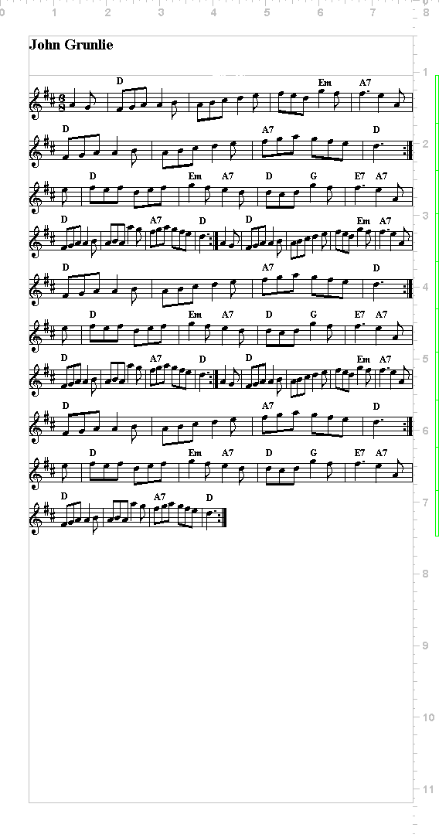Originally taught to Hoxon Hundred by
Trevor Owen March 1994
Modified by Jane Pearse and the Hoxon Hundred Garland Side November 2004. Modified for 3 dancers 2013 (different notation). Taught to Danegeld 2017. Now there’s a version for 4 (see end)

Music – John Grunlie AABB
Outside foot start
Ribbon sticks held in centre
All polkas – same arm as leg. Shake stick

Figures STEP UP
GIPSY FORWARD
CORNERS
STEP UP
GYPSY BACK
REEL ON SIDE
STAR
Dance positions
CALLER
1 2
3 4
5 6
7 8
REEL ACROSS
STEP UP
SINGLE LINE
STEP UP
FINAL FIGURE
Start with arms by sides. Bring up on first step

STEP UP
4 march forward - arms above shoulders, sticks horizontal
2 march on the spot - arms down
Double kick - inside, outside. Arms up. Sticks horizontal just above shoulders
4 steps backwards - arms down,
2 polkas on spot – same arm as leg over. Shake stick

GYPSY FORWARD Ending in two lines

No 3 and 4, 7 and 8.
2 polka towards centre of set (facing front)
2 polkas forward to end in line between
1 and 2, 4 and 5
2 polkas sideways, 2 on the spot

Step up - all together in two rows of four
Reverse (back to place)
No 3 and 4, 7 and 8.
2 polkas backwards
2 polkas sideways back to place
No 1 and 2, 5 and 6
2 polka sideways, 2 polkas on the spot

CORNERS CROSS

1st diagonals (1 and 4)(5 and 8)
2 steps in (arms down), meeting diagonal partner by right shoulder
Double kick (arms up)
2 polkas back to place - alternate arms
Meanwhile: 2nd diagonals face diagonally across
4 polkas on spot - alternate arms
Repeat above with 2nd corners meeting, 1st corners on spot

STEP UP
GIPSY BACK

No 3 and 4, 7 and 8.
1 polka to turn inwards to face bottom of set
1 out, 2 polkas on the spot
No 1 and 2, 5 and 6
1 polka to turn to bottom of set and move in
1 polka sideways to centre of set
2 polkas forward into line between the second couples

STEP UP- all together in 2 rows of 4, towards bottom of set
Reverse
No 1 and 2, 5 and 6
2 polkas backwards
2 polkas sideways back to place (remain facing bottom of set)
No 3 and 4, 7 and 8
3 polkas facing bottom of set
1 polka to turn by outside to face top
End position is ready to start reel.

REEL ON SIDE
Both sides of set
Pass by right, then left. People starting at the end will pass two people per sequence. People moving from middle to end, pass one.
4 march forward (arms up); 2 on spot (arms down); double kick on spot (arms up)
At ends, turn by right on 2 on the spot and kick facing next person

Start |  |  | After 1st sequence |  |  | After 2nd |  |  | After 3rd |  |  | After 4th (home)
1 | 2 |  | 3 | 4 |  | 7 | 8 |  | 5 | 6 |  | 1 | 2
3 | 4 |  | 7 | 8 |  | 5 | 6 |  | 1 | 2 |  | 3 | 4
5 | 6 |  | 1 | 2 |  | 3 | 4 |  | 7 | 8 |  | 5 | 6
7 | 8 |  | 5 | 6 |  | 1 | 2 |  | 3 | 4 |  | 7 | 8

STAR (effectively all-cross through, passing shoulder tightly in centre)

1,2,7,8 (ends) 4 polkas to outside corner ending facing centre (2 to arrive, 2 to face centre)
3,4,5,6 (centre 4) 3 polkas into middle of set facing in. 1 polka to turn to face out to corner.

Centres move out to corner - 4 steps (up), 2 steps to turn to face centre (down), 2 kicks (up)
Corners change with centres passing by right in 4 steps (up). Cross beyond middle to face diagonal opposite in 2 steps (down) Kick-Kick, facing corner.
Repeat another three times.
Four polkas to form two lines of 4 across set. Turn to reel position on step 4.

REEL ACROSS
Same moves as reel on side

4 steps, 2 on spot, Kick - kick to meet right shoulder, Kick, kick.
Progress in 3 moves back to position
4 polkas back to original set position

STEP UP

SINGLE LINE
2 polkas to face across set
2 polkas in to centre to form a single line, meeting by right shoulder
2 steps around partner (arms down) to face opposite direction to outside of set, Kick, Kick (arms up)
Ends (when not moving) face in direction that they arrived and step on the spot.
Progress until at the opposite end of set facing to original side of set (8 changes)
4 polkas out to original side of set. (Set is now reversed)
2 1
4 3
6 5
8 7
STEP UP

FINAL FIGURE
4 steps (hand up) facing forward.
Back 2 (2&1) move diagonally forward into line across with 4 and 3
Front 2 (8&7) move diagonally back into a line across with 6 and 5
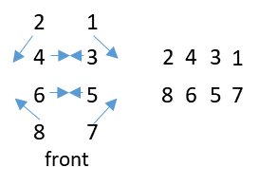Middle 4 move sideways closer together
All
2 steps on spot (arms down) Kick, kick (up)
Polka, polka (alternate)
3 kicks both arms above shoulders
– On 4th kick, stamp leg down – bring arms down

Dance off: Polka alternate arms in clockwise circle. All the way around. No 1 leads off

VERSION for four dancers

Changes
Start Positions
4 3
2 1
Front

No Change for Step up, Gypsy forward, Corners

Reel on the side becomes Reel in the Centre

On the drop-back from Gypsy Back Polka into single central line

3
4
2
1

Star: All dancers move to an outside corner: Pass left in centre. Turn by Right at outside. Do down, down, Kick, kick facing centre.

4 3 1 2 4 3
1 2 4 3
3 4 2 1
2 1 3 4 2 1

4 polkas into reel across
Reel across 2 4 3 1
4 polkas back to set
Step up (normal)
Single line – 2 polkas to face; 2 polkas to meet right shoulder in the middle. Changes same but up and down line twice. All change position; middle change, ends stay still; all change, middle change, ends stay still and rpt . 4 polkas forward out to set
Step up
Final Figure – Back 2 positions move forward to outside to form single line.

