Horwich
Barren Rocks of Aden
March 2013
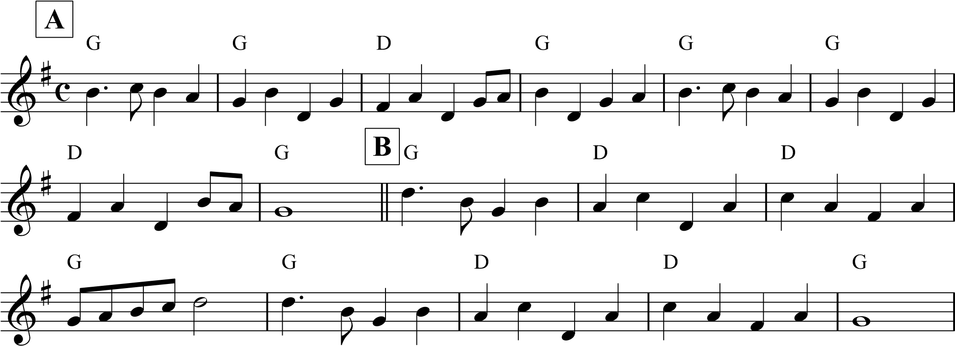
Johnny Mickey Barry's
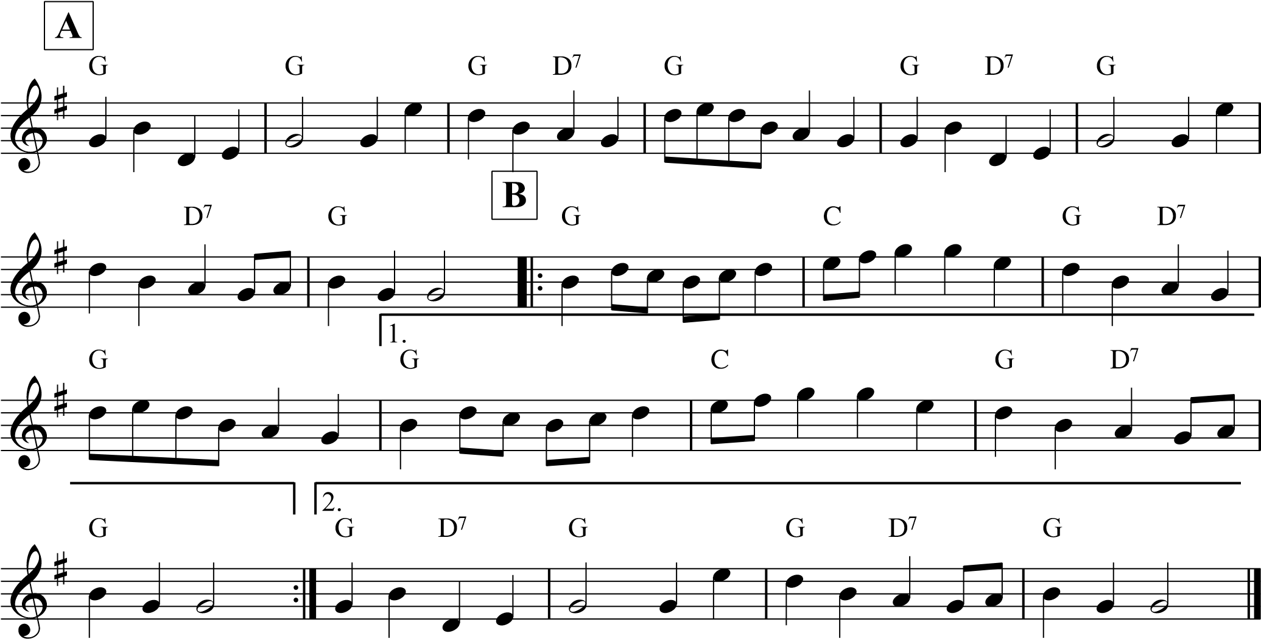
Barren Rocks of Aden Chorus to A's
ABB Cast
AB Crossover
AB Star Right AB Star Left
Johnny Mickey's
ABBBB Feather
ABB Reel
ABB Horwich
4 Drum Beats
ABB Dance off to Barren Rocks

