We’ve been going for over 30 years now and still love dancing together!
We’re a friendly group and always welcome new dancers and musicians.
Come and join us; meet new people; get fit and most importantly have fun!
We practise at Bredfield Village Hall, near Woodbridge IP13 6AX every Tuesday between 8.00 and 10.00 p.m.

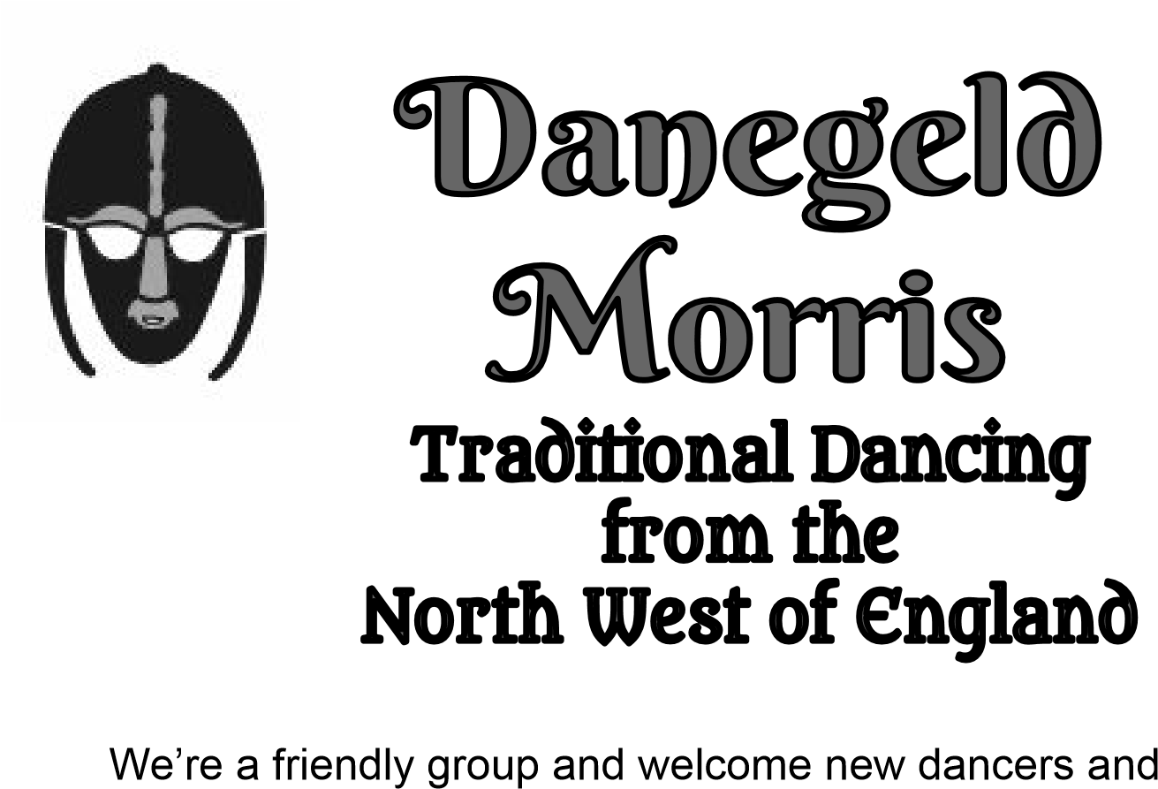

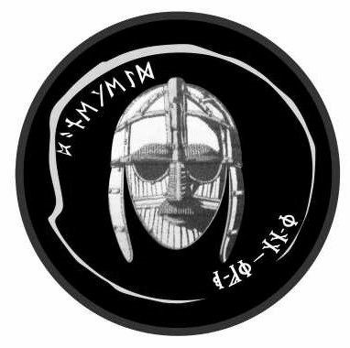

Danegeld Morris
Danegeld Morris started in 1988; the first mixed gender Morris side in South Suffolk.

Many original members had enjoyed dancing in men’s or women’s sides but wanted the chance to dance with friends and partners.

We continue to welcome people regardless of gender, age, ethnicity, religion, health or learning difference and remain convinced that accepting people for who they are, and treating everyone with care and respect, is vitally important.

We strive to achieve this within our group whether at practise or when dancing out.

Statement of Purpose
Our purpose is to be a social organisation for the enjoyment of our members through the teaching, learning and practice of traditional forms of dance, particularly dances in the style of North-West Morris.

Danegeld Morris welcome everyone, regardless of age, ethnicity, gender, religion, health or learning difference.

Danegeld Morris members are expected to respect all other members, both in person and any forms of communication.

Membership commences upon payment of the first subscription fees.

North-West Morris: A Brief History

North-West Morris dancing originates from street processions, danced through the industrial towns of Lancashire and Cheshire.

Early 19th Century archives mention local dancers accompanying rush carts in ceremonial processions when new rushes were laid on church floors, to help conserve heat over the winter months

.
Occasionally fights flared between rival teams of dancers and this led to a drop in popularity, exacerbated by the arrival of the train and the availability of cheap trips to the seaside.

Whilst several dance sides kept going until the First World War, and some even after that, the number of sides kept dropping until the folk revival of the 1970s prompted a renaissance.

Since then, the tradition has grown and now Morris teams perform regularly, everywhere for your - and our - entertainment.

We are proud to be a mixed gender side. Pictures from the 1820’s show dancers in both male and female dress, proving North-West Morris has always been for both sexes.

We are always looking for new dancers and musicians, so why not come and meet us?

One distinctive aspect of North-West Morris lies in our colourful and distinctive costumes. Originally, these were the property of the town council but nowadays each side creates their own outfits in their own style.

Ours are a bright mix of gold, red, green, and black, with the Sutton Hoo helmet motif on our backs.
Our clogs are now made by specialists: back then, they were part of everyday wear and so the dances were created to use their rhythm as an essential part of each North-West dance.

For more details please contact:
Linda 07970 957992
info@danegeldmorris.org.uk
Updated February 2024

